Linear Regression Tutorial Sheet Solutions

MYPEARSON<-read.csv("PearsonLeeSimple.csv")  
Pearson_child_parent<-lm(child~parent,data=MYPEARSON)  
summary(Pearson_child_parent)

##   
## Call:  
## lm(formula = child ~ parent, data = MYPEARSON)  
##   
## Residuals:  
## Min 1Q Median 3Q Max   
## -12.9671 -3.5040 0.0329 3.1855 13.8013   
##   
## Coefficients:  
## Estimate Std. Error t value Pr(>|t|)   
## (Intercept) 41.06911 2.41880 16.98 <2e-16 ***  
## parent 0.38422 0.03711 10.36 <2e-16 ***  
## ---  
## Signif. codes: 0 '***' 0.001 '**' 0.01 '*' 0.05 '.' 0.1 ' ' 1  
##   
## Residual standard error: 4.81 on 744 degrees of freedom  
## Multiple R-squared: 0.126, Adjusted R-squared: 0.1248   
## F-statistic: 107.2 on 1 and 744 DF, p-value: < 2.2e-16

library(ggplot2)

## Warning: package 'ggplot2' was built under R version 3.6.1

Pearson_child_height_gp_model<-lm(child~parent,data=MYPEARSON)  
  
summary(Pearson_child_height_gp_model)

##   
## Call:  
## lm(formula = child ~ parent, data = MYPEARSON)  
##   
## Residuals:  
## Min 1Q Median 3Q Max   
## -12.9671 -3.5040 0.0329 3.1855 13.8013   
##   
## Coefficients:  
## Estimate Std. Error t value Pr(>|t|)   
## (Intercept) 41.06911 2.41880 16.98 <2e-16 ***  
## parent 0.38422 0.03711 10.36 <2e-16 ***  
## ---  
## Signif. codes: 0 '***' 0.001 '**' 0.01 '*' 0.05 '.' 0.1 ' ' 1  
##   
## Residual standard error: 4.81 on 744 degrees of freedom  
## Multiple R-squared: 0.126, Adjusted R-squared: 0.1248   
## F-statistic: 107.2 on 1 and 744 DF, p-value: < 2.2e-16

ggplot(MYPEARSON, aes(x=parent, y=child)) +ylab("Child Height (in)")+xlab("Parent Height (in)")+  
 geom_point(shape=1) +  
 scale_colour_hue(l=50) + # Use a slightly darker palette than normal  
 geom_smooth(method=lm, # Add linear regression lines  
 se=FALSE)+ # Don't add shaded confidence region  
 scale_color_discrete(name = "Parent")

## Scale for 'colour' is already present. Adding another scale for  
## 'colour', which will replace the existing scale.

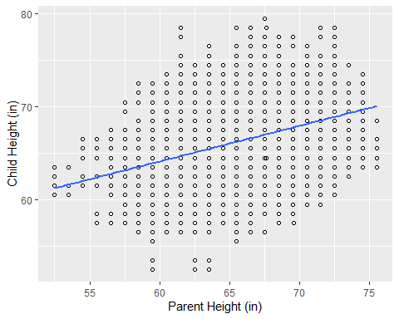

ggsave("Linear_Regression.png",dpi=300, width = 4, height = 2)